Key features of ForestClaw… Key features of ForestClaw
ForestClaw is a parallel, multi-block library for solving PDEs on adaptively refined logically Cartesian meshes.
Some of the features of ForestClaw are : 
Based on the highly scalable grid management library p4est (www.p4est.org) 
Multi-block capabilities extends the usefulness of Cartesian mesh methods to many important domains, including the cubed sphere, and non-square rectangular regions. 
Quad-tree adaptive meshing means that less meta-data is stored on each processor, and nearest-neighbors are easy to find. 
Cartesian grid layout of each patch  and regular neighbor patterns greatly simplifies the development of novel numerical methods. 
ForestClaw has been extended by several popular libraries, such as Clawpack and GeoClaw (www.clawpack.org).Brian Kyanjo (PhD in Computing, Boise State Univ.)… Brian Kyanjo (PhD in Computing, Boise State Univ.)
Donna Calhoun (Dept. Math, BSU)
Collaborators : C. Burstedde (Univ. of Bonn); S. Aiton (BSU); J. Snively (ERAU); M. Shih (NYU)Results : Four examples… Results : Four examples
Scalar advection, SWE, Euler, Acoustics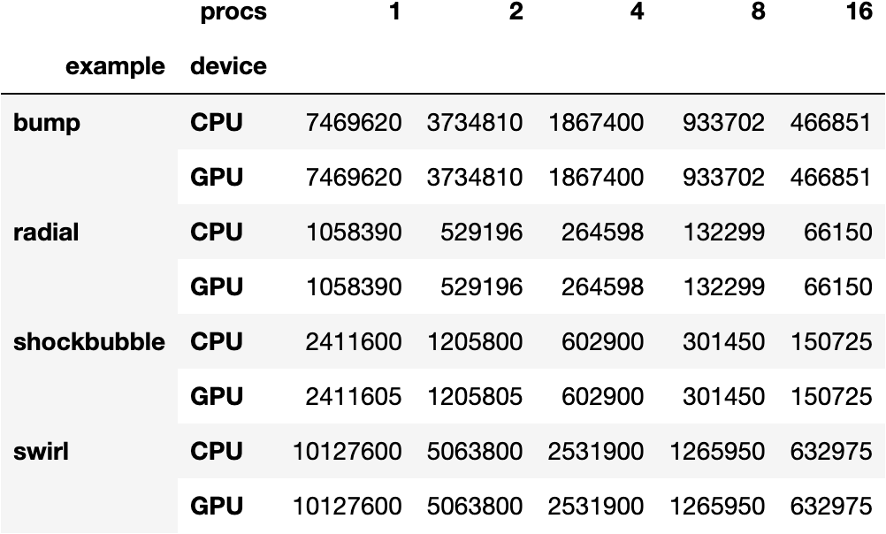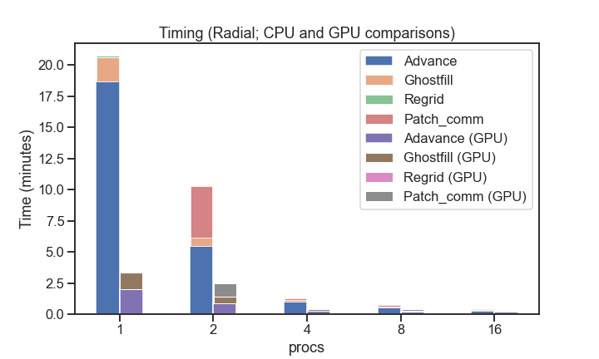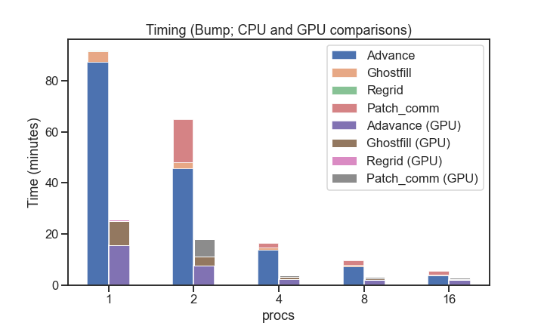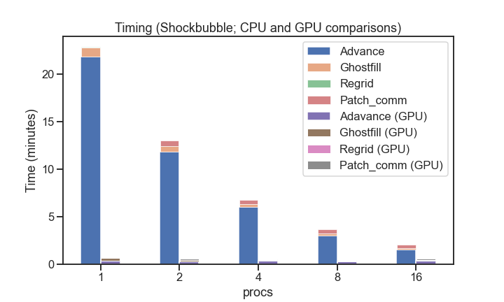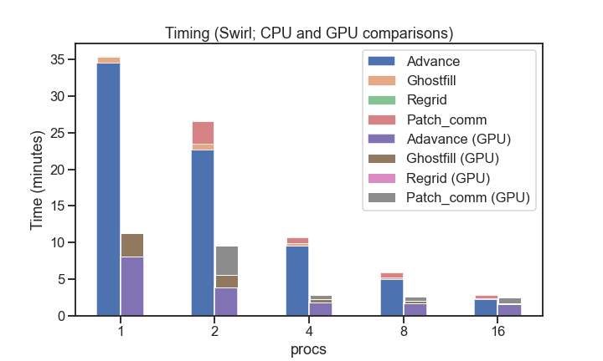

[www.forestclaw.org](http://www.forestclaw.org)



This worked is supported by NASA grant #80NSSC20K0495 (J. Snively, M. Zettergren (Embry-Riddle Aeronautic University, FL); D. Calhoun (BSU)

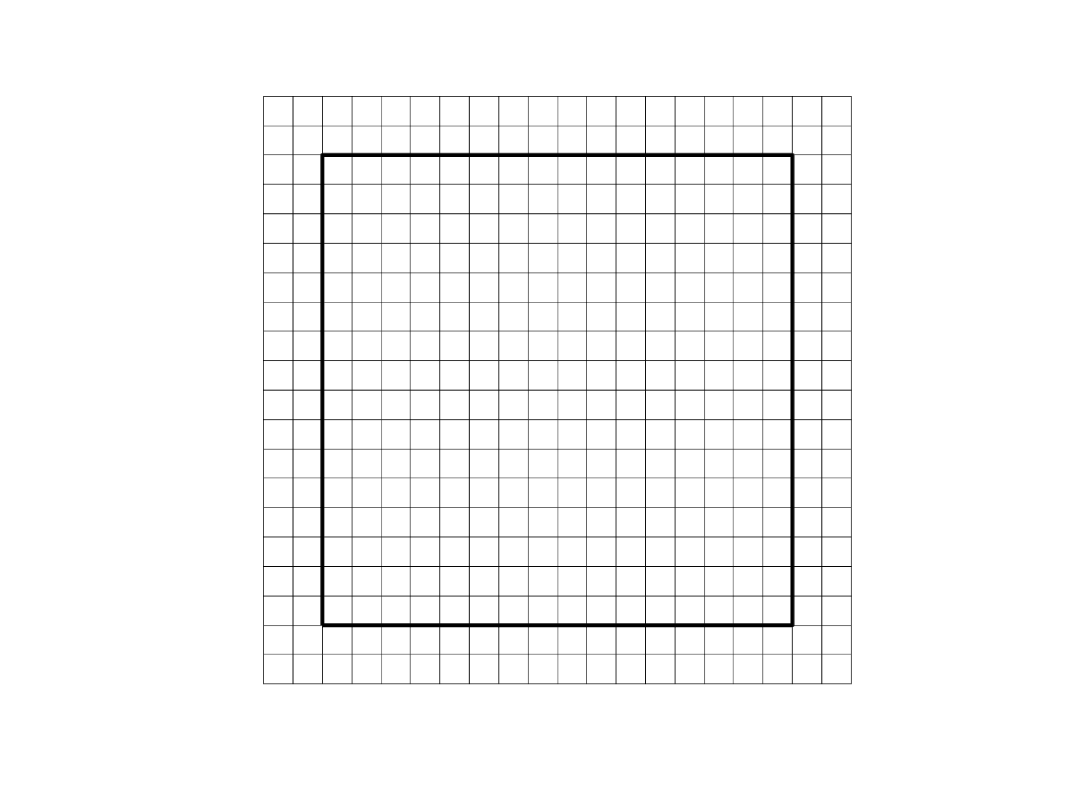

ForestClaw patches with ghost cells

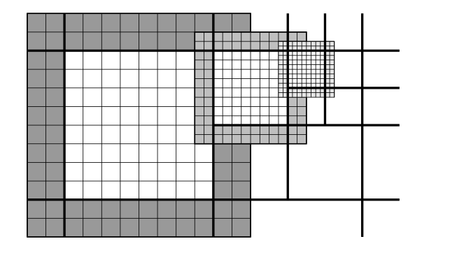

Quadtree of patches

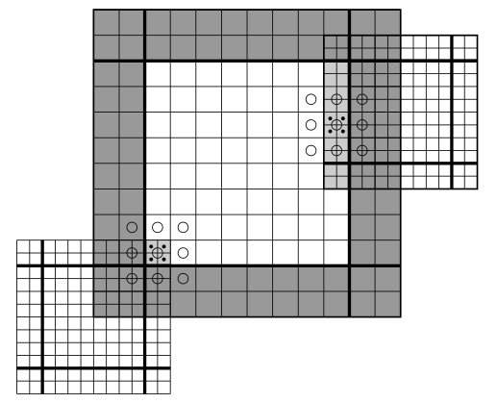

Filling fine grid patches by interpolation

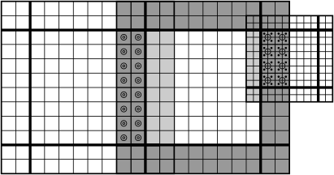

Filling coarse grid ghost cells by averaging

block_size = 128; batch_size = 4000;

mwork = 9*meqn + 9*maux + mwaves + meqn*mwaves;

bytes_per_thread = sizeof(double)*mwork;

bytes = bytes_per_thread*block_size;

dim3 block(block_size,1,1);

dim3 grid(1,1,batch_size);

claw_flux2<<<grid,block,bytes>>>(mx,my,meqn,..)

dim3 grid(1,1,batch_size);

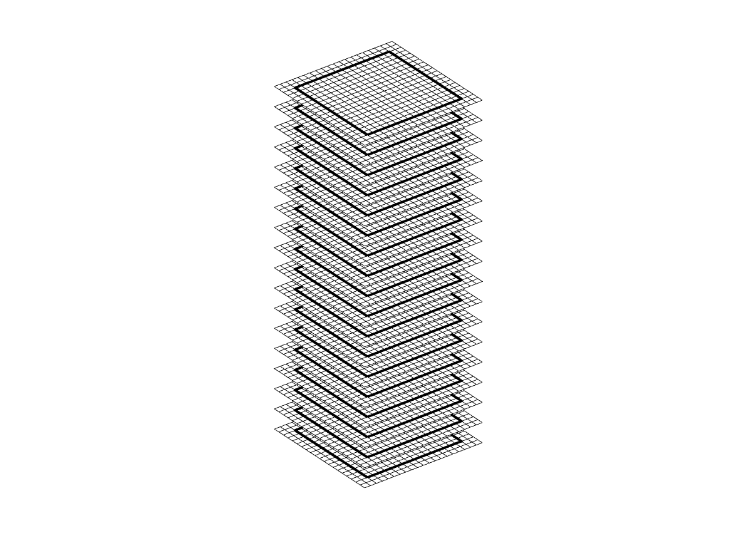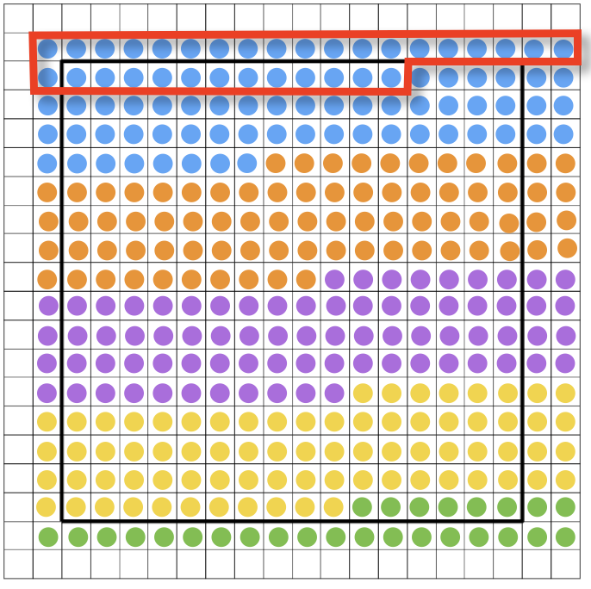

Single thread block reused per patch. Warp of 32 threads run simultaneously

Advance steps counter

